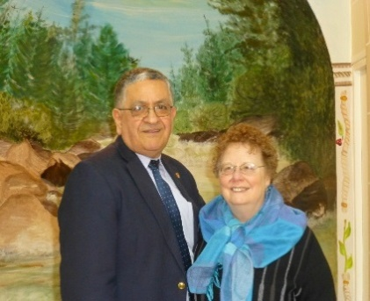

Your Rose in Paris
4 Rue Deodat de Severac
Paris, France
Nov/Dec 2018
(From the USA dial: 0-11-33-1-46-22-07-41)
(Roland cell phone 0-11-750-23-63-83)
Rose's cell phone 0-11-06-02-69-75-19
E-Mail: rolandmohsen@yahoo.com
Rose:yourroseinparis2003@yahoo.com
yourrose2009paris@gmail.com
Church website: www.egliseduchrist-deodat.com

Dear Ladies,
We had nice holidays with Rose Mary and family, some brethren and some friends. Despite all the problems in Paris we are safe, although they broke car windows on our street and in the next street over they broke many windows and stole from stores. During this time I had trouble walking for a couple of weeks with sciatic problems and my rheumatism flared up so now have medicine from the doctor and doing better. Arthritis in spinal cord with possible damage to the sciatic nerve. Now I'm walking much better. Thanks for all the prayers.
My studies with Adam, Stephanie and Jean Jacques are going well. Except for the last 2 weeks I had mostly just one little boy in Bible class. He is a joy. Ayden is his name.
We are still in Paris everyone and will probably be here for a couple of more years. Our son is not coming here to stay and preach. Just wanted to clarify this.
Am very sad to say that our beloved brethren Clyde Barber and Paul Besse died in December. Please pray for their families. Marie Fenestil's Mother also died so please pray for their family also.
I enjoyed the fellowship with the Lord's church in Lille, France. The lessons were great and was nice to see everyone. We were eighty there.
Thank you all who pray for us and support us in so many ways. God is blessing us as I was able to help Ophelie 25 years old get ready for her baptism. so each time it is a blessing to have a new soul in the Kingdom. Love Rose

